This test has two parts.
PART 1
Circle the correct letter (a, b, c or d) for each question. Write answers to the questions in the spaces provided.
1 Which of the following statements is an inference?
a I am feeling hot.
b He has fair hair.
c It will be hot tomorrow.
d Running made you sweat.
Give a reason for your answer.
__________________________________________________________________
__________________________________________________________________
(I 3.3)
2 Which of the following is the best definition of an inference?
a a possible answer to a problem
b an explanation of an observation
c a forecast of what may happen in the future
d information collected by the senses or instruments
Give an example of an inference that could relate to a skateboard rider and his broken arm.
__________________________________________________________________
__________________________________________________________________
(I 3.3)
3 Which of the following would you probably discuss in the stage of Processing in an experiment?
a a description of the equipment used
b what the scientist thinks they found out
c how the scientist used their equipment
d a list of all the measurements the scientist made
Give a reason for your answer.
__________________________________________________________________
__________________________________________________________________
(I 3.3)
4 A variable is:
a data collected in an experiment by using measuring instruments
b an explanation of the results of an experiment
c anything which can change and affect the results in an experiment
d the differences in the results from the different trials in an experiment
Give an example of a variable that may relate to how fast an athlete runs a race.
__________________________________________________________________
__________________________________________________________________
(I 3.1)
5 In an experiment, scientists always do more than one ‘trial’. This means they repeat their measurements several times.
Why do they do more than one trial?
a so they can find an average
b so they can draw a graph
c because the results are more likely to be accurate
d because they can do more calculations
Give a reason for your answer.
__________________________________________________________________
__________________________________________________________________
(I 4.1)
6 When drawing a line graph of an experiment, which data do we put on the horizontal axis?
a the independent variable
b the responding variable
c the controlled variable
d the dependent variable
Why do we do this?
__________________________________________________________________
__________________________________________________________________
(I 4.1)
The following information is needed for questions 7 and 8.
Some students were trying to find out which balls bounced highest when they were dropped from a table, onto the floor. They tested several types of balls, and measured the height they bounced up. Their results are shown in the table below:
Type of ball | Bounce height  Trial 1 (cm) | Bounce height  Trial 2 (cm) | Bounce height  Trial 3 (cm)
Golf | 80 | 82 | 84
Tennis | 40 | 45 | 42
Cricket | 32 | 34 | 36
Table tennis | 70 | 73 | 75
7 Why did they do three trials?
a to practise bouncing the balls
b they could see what would happen
c so it was a fair test
d so they could not be wrong
What do you think the results showed?
__________________________________________________________________
__________________________________________________________________
(I 3.1)
8 What variable was tested in this experiment?
a the bounce height
b the type of ball
c the number of trials
d the dropping height
Give a reason for your answer.
__________________________________________________________________
__________________________________________________________________
(I 3.1)
The following information is needed for questions 9 to 13.
Some students did an experiment to find the strength of different brands of plastic shopping bag. They cut the bags into strips and put some weights on the end to see how much weight the strips could hold until they broke. The students measured the length of each strip as each weight was added and until the bag broke. The diagram below shows how they put the weights on.
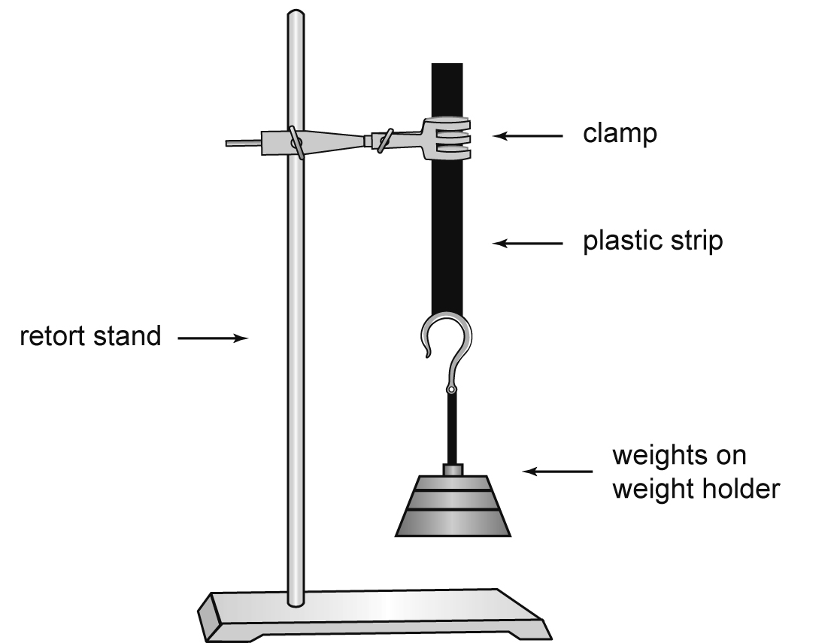
9 What was the independent (manipulated) variable in this experiment?
a the weight added
b the length of the plastic strip
c the brand of shopping bag
d the strength of the plastic strip
Give a reason for your answer.
__________________________________________________________________
__________________________________________________________________
(I 4.1)
10 What was the dependent (responding) variable?
a the weight which could be carried
b the width of the plastic strip
c the length of the plastic strip
d the type of plastic
Give a reason for your answer.
__________________________________________________________________
__________________________________________________________________
(I 4.1)
11 Which of the variables below would be the most important to control in this experiment?
a the day when they did the experiment
b the type of metre rule they used
c the brand of weights they added
d the width of each plastic strip
Give a reason for your answer.
__________________________________________________________________
__________________________________________________________________
(I 4.1)
12 What would the students be recording in this experiment?
a the weight added and the length of the strip
b the length and the height of the plastic
c the width and length of the plastic
d the weight added and the width of the plastic
Give a reason for your answer.
__________________________________________________________________
__________________________________________________________________
(I 3.1)
13 A student said this in the experiment: ‘The plastic will break if we add any more weights’. This statement can be called:
a an inference
b an observation
c a prediction
d a variable
Give a reason for your answer.
__________________________________________________________________
__________________________________________________________________
(I 3.1)
The following information is needed for questions 14 and 15.
Some students did an experiment to find out how fertilisers affect plant growth. They put some plants into different pots and added different amounts of fertiliser to them. The results are shown below:
Amount of fertiliser  (grams) | Length of plant stem  (cm)
0 | 2
1 | 4
3 | 9
4 | 10
5 | 10
6 | 8
7 | 4
14 What do you think the plant length would have been if the students had used 2 grams of fertiliser?
a 3 cm
b 10 cm
c 12 cm
d 7 cm
Give a reason for your answer.
__________________________________________________________________
__________________________________________________________________
(I 4.3)
15 What was the measure of plant growth in this experiment?
a amount of fertiliser
b length of plant stem
c height of the plant
d mass of fertiliser
Give a reason for your answer.
__________________________________________________________________
__________________________________________________________________
(I 3.1)
PART 2
Answer on the lined paper. Draw the graph on the graph paper.
1 The results below show how John’s mass (weight) in kilograms changed as he grew. There was no measurement made when he was 5.
Age (years) | 0 | 1 | 2 | 3 | 4 | 5 | 6 | 7 | 8 | 9 | 10 | 11 | 12 | 13
Weight (kg) | 2.5 | 4 | 5 | 7 | 11 |  | 15 | 19 | 25 | 27 | 30 | 33 | 35 | 36
a Draw a graph of John’s weight on the graph paper.
b Use your graph to infer what John’s weight was when he was 5.
c Use the graph to predict John’s weight when he is 14.
(I 4.3)
Level guide for teacher use
TOTALS
QUESTIONS ANSWERED AT LEVEL 2 __________
QUESTIONS ANSWERED AT LEVEL 3 __________
QUESTIONS ANSWERED AT LEVEL 4 __________
ESTIMATED LEVEL AT PRESENT __________
PART 1
Question number | Answer | Reason/written answer | Level
1 | d | d explains what has happened; c is a prediction as it is saying what will happen in the future; a and b are observations because they are using the senses to detect something. | I 3.3
2 | b | He broke his arm when he fell off his skateboard. | I 3.3
3 | b | The others are about conducting. | I 3
4 | c | Their health, fitness, age, weight, wind conditions, etc.
5 | c | There is less chance of getting unusual results if there are a lot of measurements—you can see a trend or pattern of similar results. | I 4.2
6 | a | It is easier to compare different graphs and to understand the graphs if they are drawn the same way around. | I 4.3
7 | c | That golf balls bounce higher. | I 3.3
8 | b | They changed the ball type to see its effect. | I 3.1
9 | c | They changed the type of bag and tested how strong it was. | I 4.1
10 | a | This was what was affected by changing the type of shopping bag. The length of the plastic strip was changed as well, but we don’t really care about  this—the important point is how much weight before it broke. | I 4.1
11 | d | A thinner strip would have broken more easily. | I 4.1
12 | a | They added weights and measured the length of the strip.
13 | c | We are forecasting something that may happen in the future. | I 3.1
14 | d | It has to be between 4 and 9. | I 4.3
15 | b | They measured the length of the stem. | I 3.1
PART 2
1 a (Level 4.3)
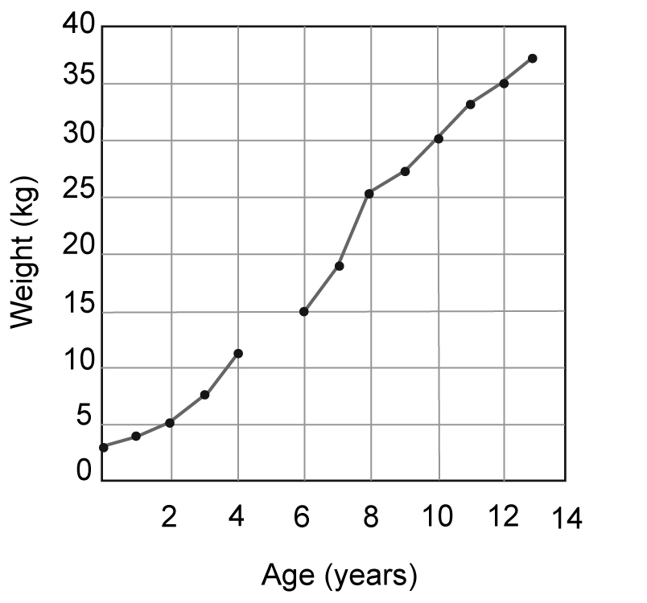
b He was about 12.5 kg at 5. (I 4.3)
c He will be about 37 kg at 14. (I 4.3)

